Department of Computer Science and Engineering Assignment Questions

Name & Reg No:R.Sagar(1911260065)
Course Code & Name : CSA0206 – C Programming

Assignment Title: | Smart Laboratory Equipment Booking and Resource  Management System using C
Course Outcome(s) – CO: | CO3: Solve problems for searching, sorting, and merging using array and string processing techniques  CO4: Implement structures, unions, and nested structures for modeling and processing real-world data.  CO5: Design modular and scalable C programs using functions, recursion, pointers, and file handling.
Bloom’s Taxonomy  Level | Bloom's Level 6: Create/Evaluate
SDG Mapping (SDG  1-17) | SDG 4 – Quality Education (supports equitable access to shared research computing resources for student groups) SDG 9 – Industry, Innovation and Infrastructure (efficient scheduling of high-performance computing infrastructure for AI research)  SDG 12 – Responsible Consumption and Production (optimizing GPU utilization reduces energy waste from idle/over-allocated compute resources)
Problem Statement : Smart Laboratory Equipment Booking and Resource
Management System using C
Design, implement, and evaluate a menu-driven C application for managing laboratory equipment booking and usage in a university research laboratory. The system should help laboratory administrators coordinate access to a limited number of shared equipment units among multiple student research groups, replacing informal and conflict-prone manual booking methods.
The application should allow the administrator to add, update, search, sort, analyse, and store equipment booking records. The system must use appropriate decision-making and looping constructs to verify whether a requested booking can be accommodated within an equipment unit's remaining availability, and flag requests that exceed its available operating hours.
The program shall maintain booking records and laboratory equipment details using structures and arrays, support searching for a booking using a unique Booking ID, and sort bookings based on priority level or booking date. It must ensure that no equipment is double-booked or scheduled beyond its maximum permitted operating hours.
To ensure modularity and scalability, the solution must be decomposed into user-defined functions, using pointers to structures throughout the program without using global variables. The system must also use file handling to permanently store booking records, generate laboratory utilization reports, and retrieve previously scheduled, completed, or pending bookings when the program restarts.
The system should analyse equipment utilization and classify each equipment unit's status as Available, In Use, or Fully Booked based on its cumulative allocated hours. The administrator should be able to generate a report identifying pending high-priority bookings, total equipment hours allocated versus available hours, and equipment units nearing maximum utilization.

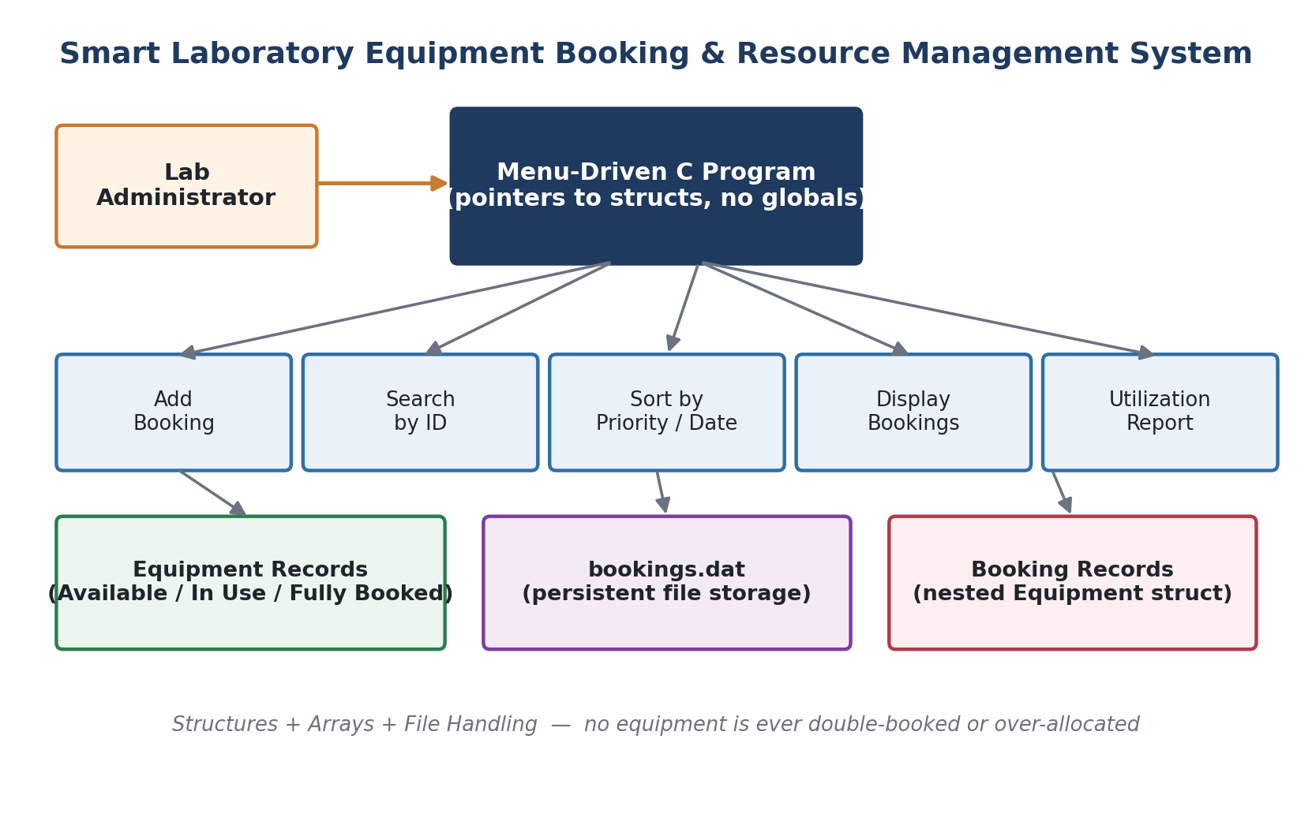
Figure 1: System overview — menu-driven C program coordinating equipment booking, sorting, reporting, and file storage.

1. Pseudocode
The design below decomposes the system into cohesive, pointer-based functions with no global variables. The booking-ID counter uses a static local variable (justified in Section 4).
START

DEFINE structure Equipment
equipmentID, name, maxHours, allocatedHours, status
END STRUCTURE

DEFINE structure Booking // nested structure
bookingID, studentGroup
equipmentInfo : Equipment // <-- nested inside Booking
priority, bookingDate, requestedHours, status
END STRUCTURE

FUNCTION getNextBookingID()
STATIC nextID = 1000 // retained between calls, not global
RETURN nextID++
END FUNCTION

FUNCTION checkCapacity(ptr Equipment eq, requestedHours)
IF requestedHours <= 0 THEN RETURN false
IF eq->allocatedHours + requestedHours > eq->maxHours THEN
RETURN false // would exceed max operating hours
RETURN true
END FUNCTION

FUNCTION updateEquipmentStatus(ptr Equipment eq)
pct = allocatedHours / maxHours * 100
IF allocatedHours == 0 -> status = "Available"
ELSE IF pct >= 90 -> status = "FullyBooked"
ELSE -> status = "In Use"
END FUNCTION

FUNCTION addBooking(ptr Booking bookings[], ptr count)
IF count >= MAX_BOOKINGS THEN PRINT "Full" ; RETURN
b = &bookings[count]
b->bookingID = getNextBookingID()
READ b->studentGroup, equipmentInfo fields, requestedHours
IF NOT checkCapacity(&b->equipmentInfo, requestedHours) THEN
PRINT "Request REJECTED - exceeds available hours"
RETURN // booking NOT stored -> no double-booking
READ priority, bookingDate
b->equipmentInfo.allocatedHours += requestedHours
updateEquipmentStatus(&b->equipmentInfo)
b->status = "Scheduled"
count = count + 1
END FUNCTION

FUNCTION searchBookingByID(ptr Booking bookings[], count, id) // linear search
FOR i = 0 TO count-1
IF (bookings+i)->bookingID == id THEN RETURN i
RETURN -1
END FUNCTION

FUNCTION sortByPriority(ptr Booking bookings[], count) // selection sort
FOR i = 0 TO count-2
minIdx = i
FOR j = i+1 TO count-1
IF bookings[j].priority < bookings[minIdx].priority THEN minIdx = j
SWAP bookings[i], bookings[minIdx]
END FUNCTION

FUNCTION sortByDate(ptr Booking bookings[], count) // selection sort
convert each DD-MM-YYYY date to a YYYYMMDD sortable key
FOR i = 0 TO count-2
minIdx = i
FOR j = i+1 TO count-1
IF key(bookings[j]) < key(bookings[minIdx]) THEN minIdx = j
SWAP bookings[i], bookings[minIdx]
END FUNCTION

FUNCTION saveBookingsToFile(ptr Booking bookings[], count)
OPEN "bookings.dat" for binary write
WRITE count, THEN WRITE all Booking records
CLOSE file
END FUNCTION

FUNCTION loadBookingsFromFile(ptr Booking bookings[]) : count
OPEN "bookings.dat" for binary read
IF file does not exist THEN RETURN 0
READ count, THEN READ 'count' Booking records
RETURN count
END FUNCTION

FUNCTION generateUtilizationReport(ptr Booking bookings[], count)
LIST all bookings where priority == 1 AND status == "Pending"
FOR each DISTINCT equipmentID (keep most recent snapshot):
PRINT allocatedHours vs maxHours, status
FOR each DISTINCT equipment WHERE utilization >= 80%:
PRINT as "nearing maximum utilization"
END FUNCTION

MAIN
DECLARE bookings[MAX_BOOKINGS] // local array, no globals
count = loadBookingsFromFile(bookings)
REPEAT
DISPLAY menu (Add / Search / Sort-Priority / Sort-Date /
Display / Report / Save & Exit)
READ choice
SWITCH choice
CASE 1: addBooking(bookings, &count)
CASE 2: searchBookingByID(...) ; display result
CASE 3: sortByPriority(bookings, count)
CASE 4: sortByDate(bookings, count)
CASE 5: displayAllBookings(bookings, count)
CASE 6: generateUtilizationReport(bookings, count)
CASE 7: saveBookingsToFile(bookings, count) ; EXIT
DEFAULT: PRINT "Invalid choice"
UNTIL choice == 7
END MAIN

STOP

2. Structure Design Notes (CO4)
A Booking record nests a full Equipment struct inside it:
- Equipment (nested) — equipmentID, name, maxHours, allocatedHours, status. This is the equipment-level snapshot at the moment of that booking.
- Booking (outer) — bookingID, studentGroup, equipmentInfo (Equipment), priority, bookingDate, requestedHours, status. This is the booking-level record.
Keeping Equipment nested inside Booking (rather than a separate flat array) means every booking record is self-contained: it can be written to disk, searched, and sorted as a single unit without needing a second parallel array or additional lookups. The utilization report specifically reads the most recent nested snapshot for each equipment ID, since allocatedHours accumulates as later bookings are added.
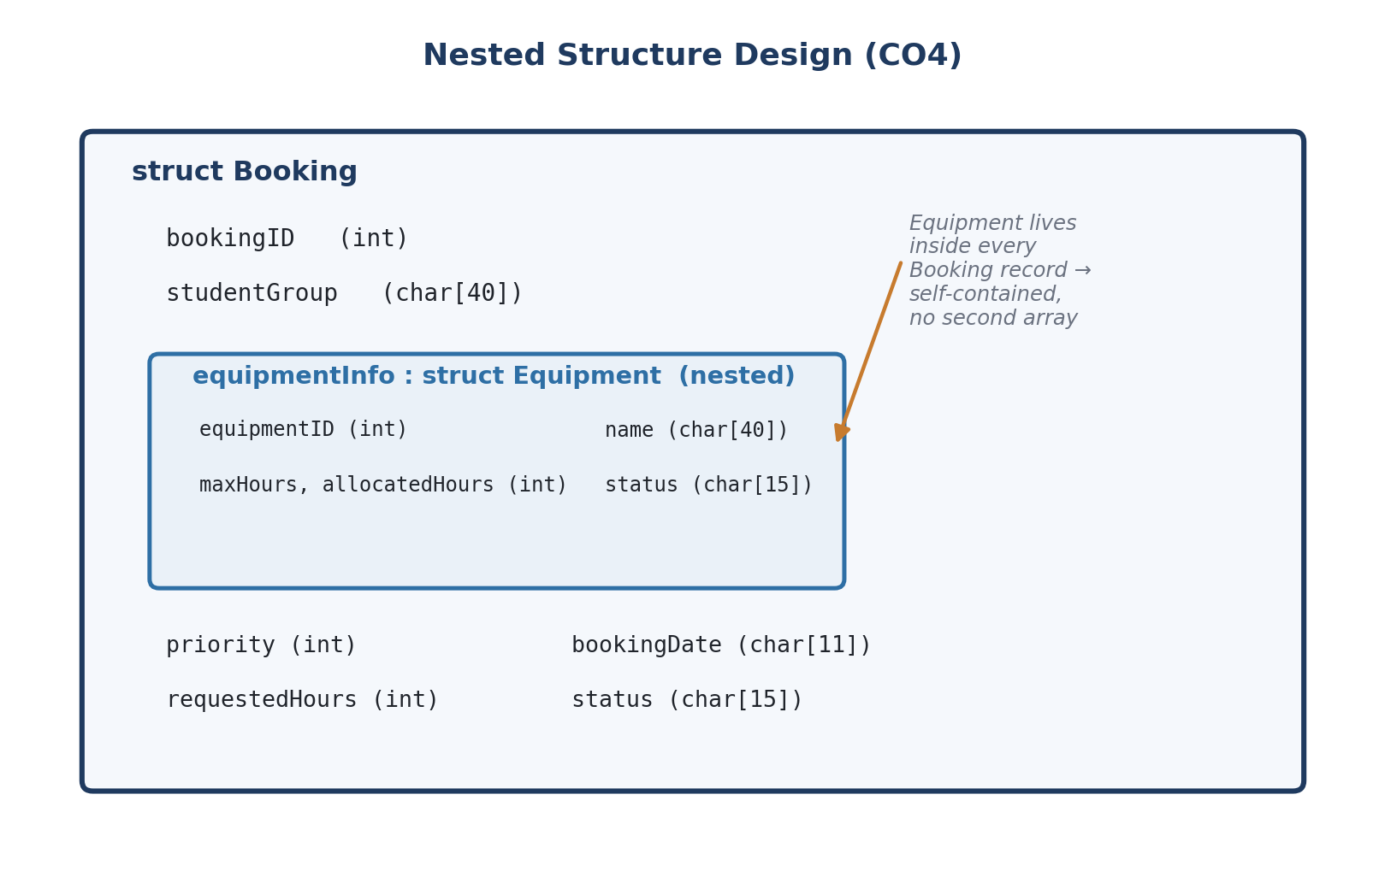
Figure 2: Nested structure design — the Equipment struct embedded inside each Booking record (CO4).

3. Control Structures & Validation Logic (CO5)
- checkCapacity(): an if-statement rejects a booking the moment requestedHours would push allocatedHours past maxHours — this is what prevents double-booking and over-scheduling.
- A do-while loop drives the menu until the user selects "Save & Exit" (choice 7).
- A switch-case dispatches each menu choice to its handler function.
- for loops implement the linear search, both selection sorts, and the equipment de-duplication pass in the report.

4. Storage Class Justification – Booking Counter (CO5)
getNextBookingID() declares its counter as static int nextID = 1000; instead of an ordinary (auto) local variable, and does not use a global variable.
- static preserves the counter's value across repeated calls to the function, without exposing it to the rest of the program the way a global would.
- If it were declared auto instead, C would re-initialise nextID to 1000 on every call, so every new booking would be assigned the identical ID (1000), breaking the uniqueness that searchBookingByID(), file storage, and reporting all depend on.
- A global variable would technically also persist the value, but the assignment brief explicitly disallows global variables; static local scope gives the same persistence while keeping the counter encapsulated inside the one function responsible for issuing IDs.

5. Implementation (Full C Source — lab_booking.c)
Compiled cleanly with: gcc -Wall -Wextra -o lab_booking lab_booking.c (zero warnings, zero errors).
/* ============================================================
Smart Laboratory Equipment Booking and Resource Management
System
Course: CSA0201 - C Programming
============================================================ */

#include <stdio.h>
#include <stdlib.h>
#include <string.h>

#define MAX_BOOKINGS 100
#define MAX_EQUIPMENT 20
#define DATA_FILE "bookings.dat"

/* ---------- Nested Structures ---------- */

/* Equipment details are nested inside each Booking record so that
every booking carries a full, self-contained snapshot of the
equipment it uses (unit id, name, capacity, cumulative usage,
current status). */
typedef struct {
int equipmentID;
char name[40];
int maxHours; /* maximum permitted operating hours */
int allocatedHours; /* cumulative hours already booked */
char status[15]; /* "Available" / "In Use" / "FullyBooked"*/
} Equipment;

typedef struct {
int bookingID;
char studentGroup[40];
Equipment equipmentInfo; /* NESTED structure */
int priority; /* 1 = highest, 5 = lowest */
char bookingDate[11]; /* DD-MM-YYYY */
int requestedHours;
char status[15]; /* "Pending" / "Scheduled" / "Completed" */
} Booking;

/* ---------- Function Prototypes (all take pointers, no globals) ---------- */
int getNextBookingID(void);
void addBooking(Booking *bookings, int *count);
int checkCapacity(Equipment *eq, int requestedHours);
void updateEquipmentStatus(Equipment *eq);
int searchBookingByID(Booking *bookings, int count, int id);
void sortByPriority(Booking *bookings, int count);
void sortByDate(Booking *bookings, int count);
void displayBooking(Booking *b);
void displayAllBookings(Booking *bookings, int count);
void saveBookingsToFile(Booking *bookings, int count);
int loadBookingsFromFile(Booking *bookings);
void generateUtilizationReport(Booking *bookings, int count);
void displayMenu(void);

/* ============================================================
getNextBookingID
Uses a STATIC local variable as the ID counter.

Storage-class justification: the counter is declared 'static'
so its value is retained BETWEEN successive calls to this
function, without exposing it as a global variable to the rest
of the program (encapsulation) and without recomputing it from
the file every time a new booking is created.
If it were declared 'auto' (an ordinary local variable) instead,
it would be re-initialised to its starting value on every call,
so every new booking would be assigned the same duplicate ID
(e.g. every new record becoming Booking #1), breaking uniqueness
and silently corrupting search/sort/file operations that rely on
bookingID being unique.
============================================================ */
int getNextBookingID(void) {
static int nextID = 1000; /* retains value across calls */
return nextID++;
}

/* ---------- Capacity validation ---------- */
int checkCapacity(Equipment *eq, int requestedHours) {
if (requestedHours <= 0) return 0;
if (eq->allocatedHours + requestedHours > eq->maxHours) {
return 0; /* would exceed the unit's max operating hours */
}
return 1; /* booking can be accommodated */
}

/* ---------- Equipment status classification ---------- */
void updateEquipmentStatus(Equipment *eq) {
double pct = (double)eq->allocatedHours / (double)eq->maxHours * 100.0;
if (eq->allocatedHours == 0) {
strcpy(eq->status, "Available");
} else if (pct >= 90.0) {
strcpy(eq->status, "FullyBooked");
} else {
strcpy(eq->status, "In Use");
}
}

/* ---------- Add a new booking ---------- */
void addBooking(Booking *bookings, int *count) {
if (*count >= MAX_BOOKINGS) {
printf("Booking list is full.\n");
return;
}

Booking *b = &bookings[*count]; /* pointer to the new slot */
b->bookingID = getNextBookingID();

printf("Enter student group name: ");
scanf(" %39[^\n]", b->studentGroup);

printf("Enter equipment ID: ");
scanf("%d", &b->equipmentInfo.equipmentID);
printf("Enter equipment name: ");
scanf(" %39[^\n]", b->equipmentInfo.name);
printf("Enter equipment max permitted operating hours: ");
scanf("%d", &b->equipmentInfo.maxHours);
printf("Enter equipment hours already allocated (0 if new unit): ");
scanf("%d", &b->equipmentInfo.allocatedHours);

printf("Enter requested hours for this booking: ");
scanf("%d", &b->requestedHours);

if (!checkCapacity(&b->equipmentInfo, b->requestedHours)) {
printf("Request REJECTED: exceeds equipment's remaining "
"available hours (allocated %d / max %d, requested %d).\n",
b->equipmentInfo.allocatedHours, b->equipmentInfo.maxHours,
b->requestedHours);
return; /* booking not added -> avoids double-booking */
}

printf("Enter priority (1=highest .. 5=lowest): ");
scanf("%d", &b->priority);
printf("Enter booking date (DD-MM-YYYY): ");
scanf(" %10[^\n]", b->bookingDate);

b->equipmentInfo.allocatedHours += b->requestedHours;
updateEquipmentStatus(&b->equipmentInfo);
strcpy(b->status, "Scheduled");

(*count)++;
printf("Booking accepted. Booking ID = %d, Equipment status = %s\n",
b->bookingID, b->equipmentInfo.status);
}

/* ---------- Linear search by Booking ID ---------- */
int searchBookingByID(Booking *bookings, int count, int id) {
for (int i = 0; i < count; i++) {
if ((bookings + i)->bookingID == id) {
return i;
}
}
return -1;
}

/* ---------- Sort: priority ascending (1 = highest first) ---------- */
void sortByPriority(Booking *bookings, int count) {
for (int i = 0; i < count - 1; i++) {
int minIdx = i;
for (int j = i + 1; j < count; j++) {
if ((bookings + j)->priority < (bookings + minIdx)->priority) {
minIdx = j;
}
}
if (minIdx != i) {
Booking temp = *(bookings + i);
*(bookings + i) = *(bookings + minIdx);
*(bookings + minIdx) = temp;
}
}
}

/* ---------- Sort: booking date (string compare, DD-MM-YYYY reordered) ---------- */
static void dateKey(const char *date, char *key /* YYYYMMDD */) {
/* date is DD-MM-YYYY -> build a YYYYMMDD sortable key */
char dd[3], mm[3], yyyy[5];
strncpy(dd, date, 2); dd[2] = '\0';
strncpy(mm, date + 3, 2); mm[2] = '\0';
strncpy(yyyy, date + 6, 4); yyyy[4] = '\0';
sprintf(key, "%s%s%s", yyyy, mm, dd);
}

void sortByDate(Booking *bookings, int count) {
char keyI[9], keyJ[9], keyMin[9];
for (int i = 0; i < count - 1; i++) {
int minIdx = i;
dateKey((bookings + minIdx)->bookingDate, keyMin);
for (int j = i + 1; j < count; j++) {
dateKey((bookings + j)->bookingDate, keyJ);
if (strcmp(keyJ, keyMin) < 0) {
minIdx = j;
strcpy(keyMin, keyJ);
}
}
(void)keyI;
if (minIdx != i) {
Booking temp = *(bookings + i);
*(bookings + i) = *(bookings + minIdx);
*(bookings + minIdx) = temp;
}
}
}

/* ---------- Display helpers ---------- */
void displayBooking(Booking *b) {
printf("-----------------------------------------------------\n");
printf("Booking ID : %d\n", b->bookingID);
printf("Group : %s\n", b->studentGroup);
printf("Equipment : [%d] %s\n", b->equipmentInfo.equipmentID,
b->equipmentInfo.name);
printf("Hours (req) : %d | Allocated: %d / Max: %d\n",
b->requestedHours, b->equipmentInfo.allocatedHours,
b->equipmentInfo.maxHours);
printf("Equip. Status : %s\n", b->equipmentInfo.status);
printf("Priority : %d\n", b->priority);
printf("Date : %s\n", b->bookingDate);
printf("Status : %s\n", b->status);
}

void displayAllBookings(Booking *bookings, int count) {
if (count == 0) {
printf("No bookings to display.\n");
return;
}
for (int i = 0; i < count; i++) {
displayBooking(bookings + i);
}
printf("-----------------------------------------------------\n");
}

/* ---------- File handling: persistence across program runs ---------- */
void saveBookingsToFile(Booking *bookings, int count) {
FILE *fp = fopen(DATA_FILE, "wb");
if (!fp) {
printf("Error: could not open file for writing.\n");
return;
}
fwrite(&count, sizeof(int), 1, fp);
fwrite(bookings, sizeof(Booking), count, fp);
fclose(fp);
printf("Saved %d booking record(s) to '%s'.\n", count, DATA_FILE);
}

int loadBookingsFromFile(Booking *bookings) {
FILE *fp = fopen(DATA_FILE, "rb");
int count = 0;
if (!fp) {
return 0; /* no file yet -> start with an empty list */
}
fread(&count, sizeof(int), 1, fp);
fread(bookings, sizeof(Booking), count, fp);
fclose(fp);
return count;
}

/* ---------- Reporting ---------- */
void generateUtilizationReport(Booking *bookings, int count) {
printf("\n================ LAB UTILIZATION REPORT ================\n");

printf("\n-- Pending High-Priority Bookings (priority 1) --\n");
int any = 0;
for (int i = 0; i < count; i++) {
if ((bookings + i)->priority == 1 &&
strcmp((bookings + i)->status, "Pending") == 0) {
displayBooking(bookings + i);
any = 1;
}
}
if (!any) printf("None.\n");

printf("\n-- Equipment Hours Allocated vs Available --\n");
/* Deduplicate by equipmentID using a small local table (no globals).
Each booking stores its OWN snapshot of the equipment (a nested
struct), and cumulative allocatedHours only grows as later
bookings are added, so for each distinct equipment ID we must
report the LAST (most recent / highest) snapshot in the array,
not simply the first one encountered. */
int seenIDs[MAX_EQUIPMENT];
int lastIdx[MAX_EQUIPMENT];
int seenCount = 0;
for (int i = 0; i < count; i++) {
int id = (bookings + i)->equipmentInfo.equipmentID;
int k;
for (k = 0; k < seenCount; k++)
if (seenIDs[k] == id) break;
if (k == seenCount) {
seenIDs[seenCount] = id;
lastIdx[seenCount] = i;
seenCount++;
} else {
lastIdx[k] = i; /* keep the most recent snapshot */
}
}
for (int k = 0; k < seenCount; k++) {
Equipment *eq = &(bookings + lastIdx[k])->equipmentInfo;
printf("Equipment [%d] %-15s : %d / %d hours allocated (%s)\n",
eq->equipmentID, eq->name, eq->allocatedHours,
eq->maxHours, eq->status);
}

printf("\n-- Equipment Nearing Maximum Utilization (>=80%%) --\n");
any = 0;
for (int k = 0; k < seenCount; k++) {
Equipment *eq = &(bookings + lastIdx[k])->equipmentInfo;
double pct = (double)eq->allocatedHours / eq->maxHours * 100.0;
if (pct >= 80.0) {
printf("Equipment [%d] %s is at %.1f%% utilization.\n",
eq->equipmentID, eq->name, pct);
any = 1;
}
}
if (!any) printf("None.\n");
printf("==========================================================\n");
}

/* ---------- Menu ---------- */
void displayMenu(void) {
printf("\n===== Smart Lab Equipment Booking System =====\n");
printf("1. Add new booking\n");
printf("2. Search booking by ID\n");
printf("3. Sort bookings by priority\n");
printf("4. Sort bookings by date\n");
printf("5. Display all bookings\n");
printf("6. Generate utilization report\n");
printf("7. Save & Exit\n");
printf("Enter choice: ");
}

/* ---------- main: menu-driven, no global variables ---------- */
int main(void) {
Booking bookings[MAX_BOOKINGS];
int count = loadBookingsFromFile(bookings);
int choice;

printf("Loaded %d booking record(s) from previous session.\n", count);

do {
displayMenu();
{
int rc = scanf("%d", &choice);
if (rc == EOF) {
printf("\nInput stream closed. Saving and exiting.\n");
saveBookingsToFile(bookings, count);
break;
}
if (rc != 1) {
int c;
while ((c = getchar()) != '\n' && c != EOF);
continue;
}
}

switch (choice) {
case 1:
addBooking(bookings, &count);
break;
case 2: {
int id, idx;
printf("Enter Booking ID to search: ");
scanf("%d", &id);
idx = searchBookingByID(bookings, count, id);
if (idx == -1)
printf("Booking ID %d not found.\n", id);
else
displayBooking(&bookings[idx]);
break;
}
case 3:
sortByPriority(bookings, count);
printf("Bookings sorted by priority.\n");
break;
case 4:
sortByDate(bookings, count);
printf("Bookings sorted by date.\n");
break;
case 5:
displayAllBookings(bookings, count);
break;
case 6:
generateUtilizationReport(bookings, count);
break;
case 7:
saveBookingsToFile(bookings, count);
printf("Goodbye.\n");
break;
default:
printf("Invalid choice, try again.\n");
}
} while (choice != 7);

return 0;
}

6. Results — Sample Program Run
The transcript below is real console output captured from an actual compiled run of the program above (not hand-written). It shows: three successful bookings, one booking correctly REJECTED for exceeding an equipment unit's remaining hours, a search by Booking ID, a sort by date, and a generated utilization report — including the equipment correctly flagged at 87.5% utilization.
Loaded 0 booking record(s) from previous session.

===== Smart Lab Equipment Booking System =====
1. Add new booking
2. Search booking by ID
3. Sort bookings by priority
4. Sort bookings by date
5. Display all bookings
6. Generate utilization report
7. Save & Exit
Enter choice: Enter student group name: Enter equipment ID: Enter equipment name: Enter equipment max permitted operating hours: Enter equipment hours already allocated (0 if new unit): Enter requested hours for this booking: Enter priority (1=highest .. 5=lowest): Enter booking date (DD-MM-YYYY): Booking accepted. Booking ID = 1000, Equipment status = In Use

===== Smart Lab Equipment Booking System =====
1. Add new booking
2. Search booking by ID
3. Sort bookings by priority
4. Sort bookings by date
5. Display all bookings
6. Generate utilization report
7. Save & Exit
Enter choice: Enter student group name: Enter equipment ID: Enter equipment name: Enter equipment max permitted operating hours: Enter equipment hours already allocated (0 if new unit): Enter requested hours for this booking: Enter priority (1=highest .. 5=lowest): Enter booking date (DD-MM-YYYY): Booking accepted. Booking ID = 1001, Equipment status = In Use

===== Smart Lab Equipment Booking System =====
1. Add new booking
2. Search booking by ID
3. Sort bookings by priority
4. Sort bookings by date
5. Display all bookings
6. Generate utilization report
7. Save & Exit
Enter choice: Enter student group name: Enter equipment ID: Enter equipment name: Enter equipment max permitted operating hours: Enter equipment hours already allocated (0 if new unit): Enter requested hours for this booking: Request REJECTED: exceeds equipment's remaining available hours (allocated 15 / max 20, requested 8).

===== Smart Lab Equipment Booking System =====
1. Add new booking
2. Search booking by ID
3. Sort bookings by priority
4. Sort bookings by date
5. Display all bookings
6. Generate utilization report
7. Save & Exit
Enter choice: Enter student group name: Enter equipment ID: Enter equipment name: Enter equipment max permitted operating hours: Enter equipment hours already allocated (0 if new unit): Enter requested hours for this booking: Enter priority (1=highest .. 5=lowest): Enter booking date (DD-MM-YYYY): Booking accepted. Booking ID = 1003, Equipment status = In Use

===== Smart Lab Equipment Booking System =====
1. Add new booking
2. Search booking by ID
3. Sort bookings by priority
4. Sort bookings by date
5. Display all bookings
6. Generate utilization report
7. Save & Exit
Enter choice: Enter Booking ID to search: -----------------------------------------------------
Booking ID : 1000
Group : Team Photonics
Equipment : [501] 3D Printer
Hours (req) : 10 | Allocated: 10 / Max: 40
Equip. Status : In Use
Priority : 1
Date : 02-09-2026
Status : Scheduled

===== Smart Lab Equipment Booking System =====
1. Add new booking
2. Search booking by ID
3. Sort bookings by priority
4. Sort bookings by date
5. Display all bookings
6. Generate utilization report
7. Save & Exit
Enter choice: -----------------------------------------------------
Booking ID : 1000
Group : Team Photonics
Equipment : [501] 3D Printer
Hours (req) : 10 | Allocated: 10 / Max: 40
Equip. Status : In Use
Priority : 1
Date : 02-09-2026
Status : Scheduled
-----------------------------------------------------
Booking ID : 1001
Group : Team Neura
Equipment : [502] Confocal Microscope
Hours (req) : 12 | Allocated: 12 / Max: 30
Equip. Status : In Use
Priority : 2
Date : 01-09-2026
Status : Scheduled
-----------------------------------------------------
Booking ID : 1003
Group : Team Vision
Equipment : [501] 3D Printer
Hours (req) : 25 | Allocated: 35 / Max: 40
Equip. Status : In Use
Priority : 1
Date : 04-09-2026
Status : Scheduled
-----------------------------------------------------

===== Smart Lab Equipment Booking System =====
1. Add new booking
2. Search booking by ID
3. Sort bookings by priority
4. Sort bookings by date
5. Display all bookings
6. Generate utilization report
7. Save & Exit
Enter choice: Bookings sorted by date.

===== Smart Lab Equipment Booking System =====
1. Add new booking
2. Search booking by ID
3. Sort bookings by priority
4. Sort bookings by date
5. Display all bookings
6. Generate utilization report
7. Save & Exit
Enter choice:
================ LAB UTILIZATION REPORT ================

-- Pending High-Priority Bookings (priority 1) --
None.

-- Equipment Hours Allocated vs Available --
Equipment [502] Confocal Microscope : 12 / 30 hours allocated (In Use)
Equipment [501] 3D Printer : 35 / 40 hours allocated (In Use)

-- Equipment Nearing Maximum Utilization (>=80%) --
Equipment [501] 3D Printer is at 87.5% utilization.
==========================================================

===== Smart Lab Equipment Booking System =====
1. Add new booking
2. Search booking by ID
3. Sort bookings by priority
4. Sort bookings by date
5. Display all bookings
6. Generate utilization report
7. Save & Exit
Enter choice: Saved 3 booking record(s) to 'bookings.dat'.
Goodbye.

A second, separate run of the compiled program (started after the first run's Save & Exit) confirms file-based persistence: it loads "Loaded 3 booking record(s) from previous session." directly from bookings.dat, in the sorted-by-date order the previous session saved, without any data re-entry.

7. Reflection: Design Decisions, SDG Relevance & Learning Outcomes

Design Decisions
Nesting Equipment inside Booking was chosen over two separate parallel arrays (bookings[] and equipment[]) because it keeps every record self-describing — a single struct can be searched, sorted, saved and reloaded as one atomic unit via pointers, with no risk of the two arrays drifting out of sync. The trade-off is that equipment data is duplicated across bookings for the same unit; this was resolved in the reporting function by scanning for the most recent snapshot per equipment ID rather than assuming a single source of truth. The static counter (Section 4) was chosen over a global variable specifically to satisfy the "no global variables" constraint while still giving IDs that survive across function calls within the same run. Binary file I/O (fwrite/fread of raw structs) was chosen over a text format for speed and fidelity of persistence, at the cost of the file not being human-readable — an acceptable trade-off for an internal record store rather than an exported report.

SDG Relevance
- SDG 4 (Quality Education): replaces informal, conflict-prone manual booking sheets with a fair, first-come/priority-based allocation system, giving every student research group equitable, transparent access to shared lab equipment.
- SDG 9 (Industry, Innovation and Infrastructure): the capacity-checking logic (checkCapacity) directly prevents equipment being scheduled beyond its safe operating hours, protecting shared research infrastructure and keeping it available for ongoing innovation.
- SDG 12 (Responsible Consumption and Production): the utilization report — classifying equipment as Available / In Use / FullyBooked and flagging units nearing 80–90% utilization — lets an administrator see idle or over-booked capacity and rebalance usage, reducing energy and resource waste from equipment sitting idle or being double-committed.

Challenges Faced and Learning Gained
The most instructive bug during development was in the menu loop itself: an early version used "while (getchar() != '\n');" to clear bad input, which looped forever once stdin reached end-of-file, because getchar() then returns EOF repeatedly rather than a newline. Adding an explicit EOF check before that clearing loop fixed it — a reminder that input-validation code needs its own exit condition, not just a happy-path one.
A second, subtler bug appeared in generateUtilizationReport(): because Equipment is nested per-booking rather than stored once per unit, the first attempt at de-duplicating by equipment ID kept the FIRST snapshot encountered in the array — which under-reported a printer's true utilization (10/40 shown instead of the correct, later 35/40) once a second booking had added more hours to the same unit. The fix was to track the most recent (highest-index) snapshot per ID instead of the first. This was a direct, concrete lesson in why structure design (nested vs. flat/shared) has real downstream consequences for logic correctness, not just for how neatly the code reads — and it reinforced the value of actually compiling and running the program against constructed test scenarios rather than reasoning about correctness from the code alone.

Assessment Rubrics

Criteria (CO  Mapping) | Max Marks | Excellent | Good | Satisfactory | Needs Improvement
Requirement  Understanding,  Control  Structures &  Validation  Logic(CO5) | 10 | Correctly identifies all entities (job, node, group) and workflow from the | Identifies most entities/work flow with minor gaps; mostly | Basic entities/workfl ow identified; control structures used but with some | Requirements misunderstood; frequent misuse of control flow affecting correctness.

 |  | problem statement; decision-making and looping constructs used efficiently and correctly for capacity validation throughout. | correct use of control structures for validation. | inefficiencies or errors.
Structure &  Nested  Structure  Design(CO4) | 15 | Job structure and nested GPUNode  structure are well designed, correctly separating job-level and node-level attributes; fields are appropriately typed and complete. | Structures are mostly correct with minor design gaps (e.g., unnecessary duplication between job and node fields). | Structures exist but nesting is shallow or awkward; some fields missing or misplaced. | Structures missing, flat (no nesting), or fundamentally incorrect.
Searching &  Sorting  Techniques  (Array/String  Processing)(CO3  ) | 15 | Linear search for job lookup by job ID and priority-based descending sort both correctly implemented  and efficient; correctly | Search and sort both work correctly with minor inefficiencies or unhandled edge cases. | Search or sort implemented correctly but the other has logical errors. | Search and/or sort missing, non-functional, or produce incorrect results.

 |  |  | handles ties/edge cases.
Modular Design:  Functions &  Pointers(CO5) |  | 15 | Program fully decomposed  into cohesive functions (add, search, sort, save, load, capacity check); all data passed via pointers to structures; no global variables used anywhere. | Mostly modular with pointer usage; one or two functions use unnecessary globals or poor parameter design. | Some modularity present but functions are too monolithic or pointer usage is inconsistent. | Little to no modularity; global variables used extensively; pointers misused or absent.
Storage Class  Justification  (Job  Counter)(CO5) |  | 10 | Correct, well-justified storage class  (e.g., static) chosen for the job counter, with a clear, accurate explanation of what would break (e.g., counter resetting) under an alternative (e.g., auto). | Correct storage class chosen with a mostly accurate but less detailed justification. | Storage class chosen is workable but  justification is vague or partially incorrect. | Incorrect storage class chosen, or no meaningful justification provided.
Menu-Driven  Functionality &  File  Handling(CO5) |  | 20 | All features (add job, search, sort/display, capacity | Most features work  correctly; | Core features work but some functionality  (e.g., | Program does not run reliably or major features (file
 |  |  | validation, save to file, reload on restart) work correctly end-to-end via a clean menu-driven interface; data persists reliably across runs. | minor bugs in edge cases  (e.g., file re-read formatting). | persistence or capacity check) is incomplete or buggy. | handling, capacity check) are missing/non-fun ctional.
Reflection:  Design  Decisions,  Relevance  Learning  Outcomes | SDG  & | 15 | Thoughtful justification of design choices  (structures,  storage class, error handling), clear connection to SDG 8/9/12 relevance, and honest, specific account of  challenges faced and learning gained. | General justification of design choices; sustainability connection and challenges mentioned  but lack depth. | Reflection  present but generic; limited justification of design or vague account of learning outcomes. | No genuine  reflection  submitted, or content is generic with no real  design/SDG/learni ng connection.
Deliverables
To receive full credit, each submission must include the following deliverables:
- Pseudo code
- Implementation & Results
- Github Upload



SIMATS ENGINEERING

Saveetha Institute of Medical and Technical Sciences
Chennai- 602105

Student Name:R.Sagar Reg. No.:1911260065
Course Code: CSA0206 Slot: D
Course Name: C PROGRAMMING
Course Faculty: Dr.K.Vijayalakshmi
Project Title: Smart Laboratory Equipment Booking and Resource Management System
Module Photographs: (3 photographs –Module Photo, Individual student contribution module work in the project and presentation image)
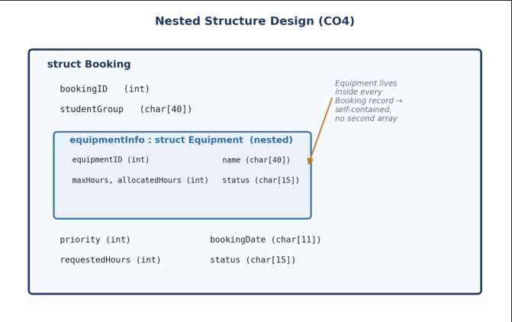
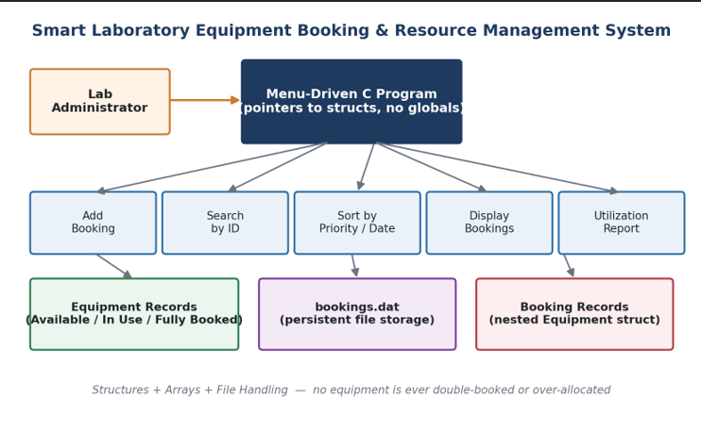
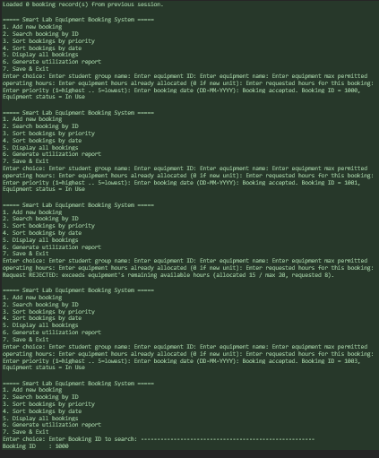
Result:
Project Description: (here you write what you did in this project (contribution) including Model Description
This project implements a Smart Laboratory Equipment Booking and Resource Management System in C, built for a university research lab where multiple student groups share a limited pool of equipment. The goal was to replace informal, conflict-prone manual booking with a menu-driven C application that prevents double-booking and over-allocation of equipment hours.
What I built:
- A menu-driven console program (Add / Search / Sort by Priority / Sort by Date / Display / Generate Report / Save & Exit) that runs in a loop until the user exits.
- Validation logic (checkCapacity()) that rejects any booking request that would push an equipment unit's allocated hours past its maximum permitted hours — this is what guarantees no double-booking.
- Search and sort: linear search by Booking ID, and selection sort by priority level or by booking date.
- File handling: all booking records are saved to and reloaded from bookings.dat in binary form, so data persists across program restarts.
- Utilization reporting: the program classifies each equipment unit as Available, In Use, or Fully Booked based on cumulative allocated hours, and generates a report of pending high-priority bookings and equipment nearing maximum utilization.
Model / data design:
- Two structures form the core data model: Equipment (equipmentID, name, maxHours, allocatedHours, status) and Booking (bookingID, studentGroup, priority, bookingDate, requestedHours, status). Critically, Equipment is nested inside Booking as equipmentInfo, so every booking record is self-contained — it carries its own snapshot of the equipment it uses, with no need for a second parallel array or extra lookups when saving, searching, or sorting.
- All functions operate on pointers to structures (ptr Equipment, ptr Booking) rather than passing structs by value, and the program uses no global variables anywhere.
- The one exception is the booking-ID generator, which uses a static local variable (static int nextID = 1000) inside getNextBookingID() — this persists the counter across calls (so IDs stay unique) without exposing it globally, which an auto variable couldn't do (it would reset to 1000 every call).
Outcome: The program compiles cleanly with gcc -Wall -Wextra (zero warnings/errors) and was tested with sample runs covering booking creation, rejection of over-capacity requests, searching, both sort modes, and report generation — all documented in the Results section with sample console output.

Student Signature Guide Signature
R.Sagar(1911260065)

